Chapter 3:
# Answer 1
Refer FunctionFile.ipynb
# Answer 2
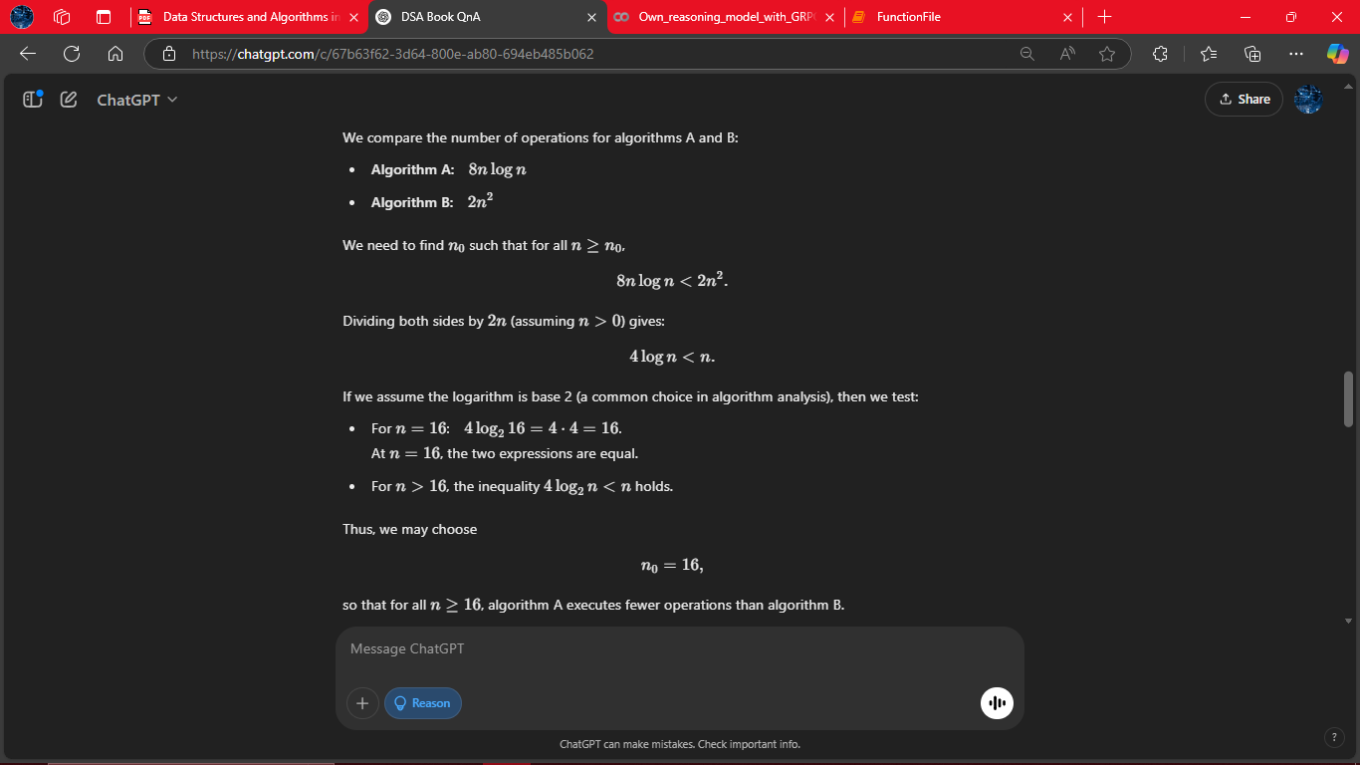
# Answer 3
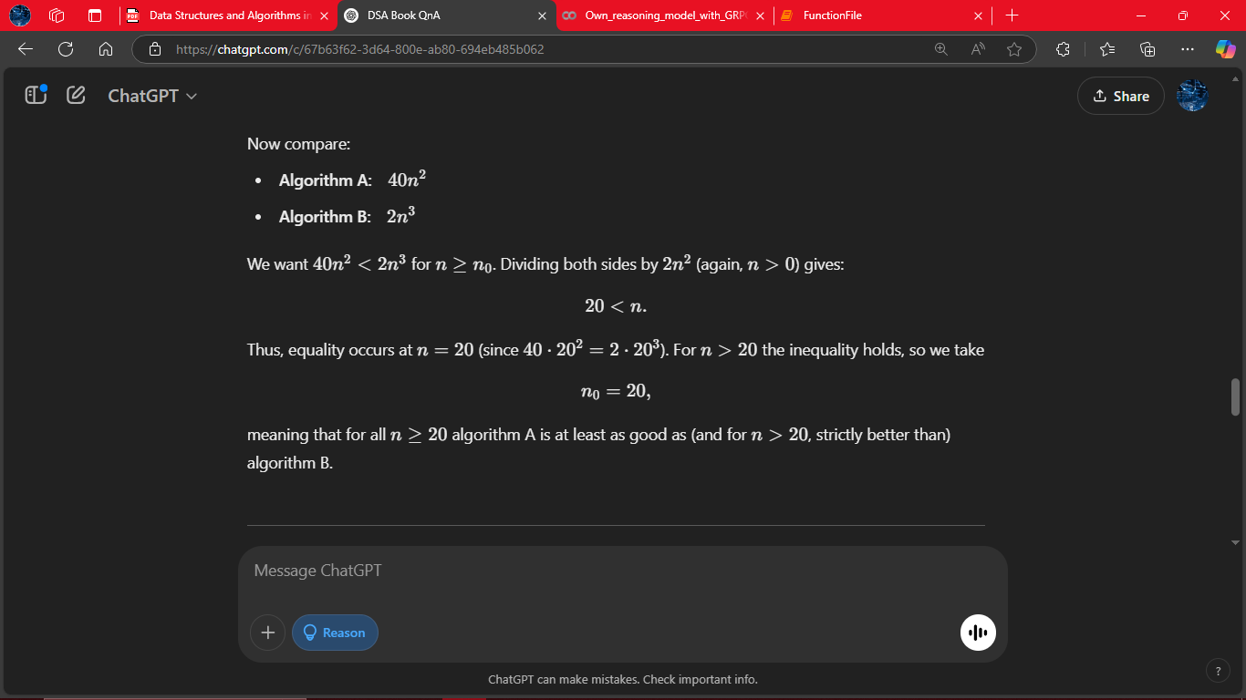
# Answer 4
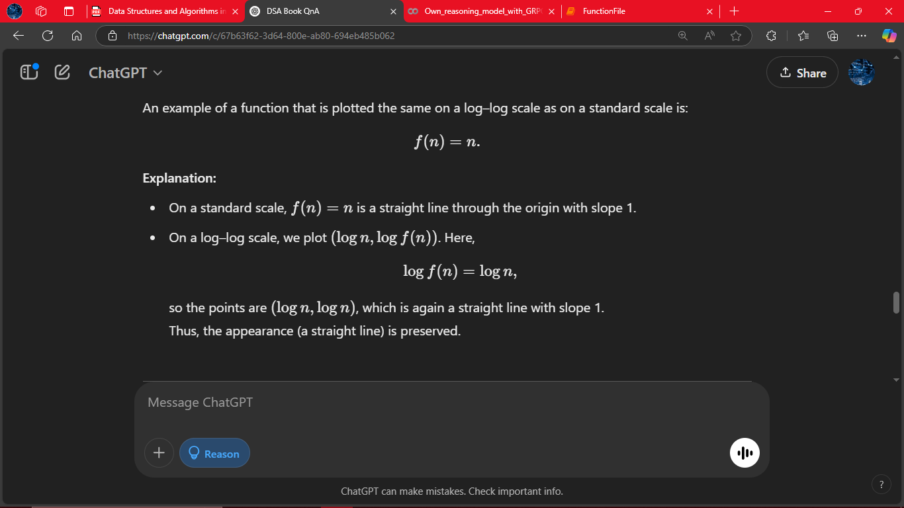
# Answer 5
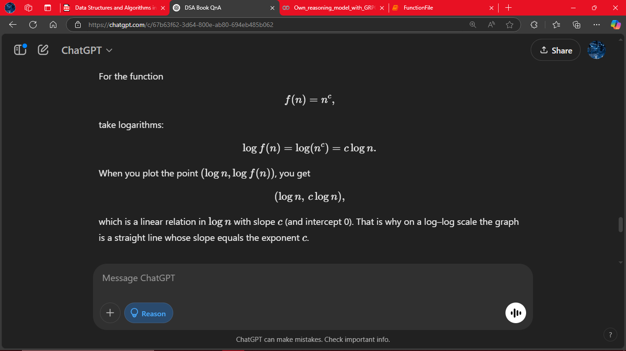
# Answer 6
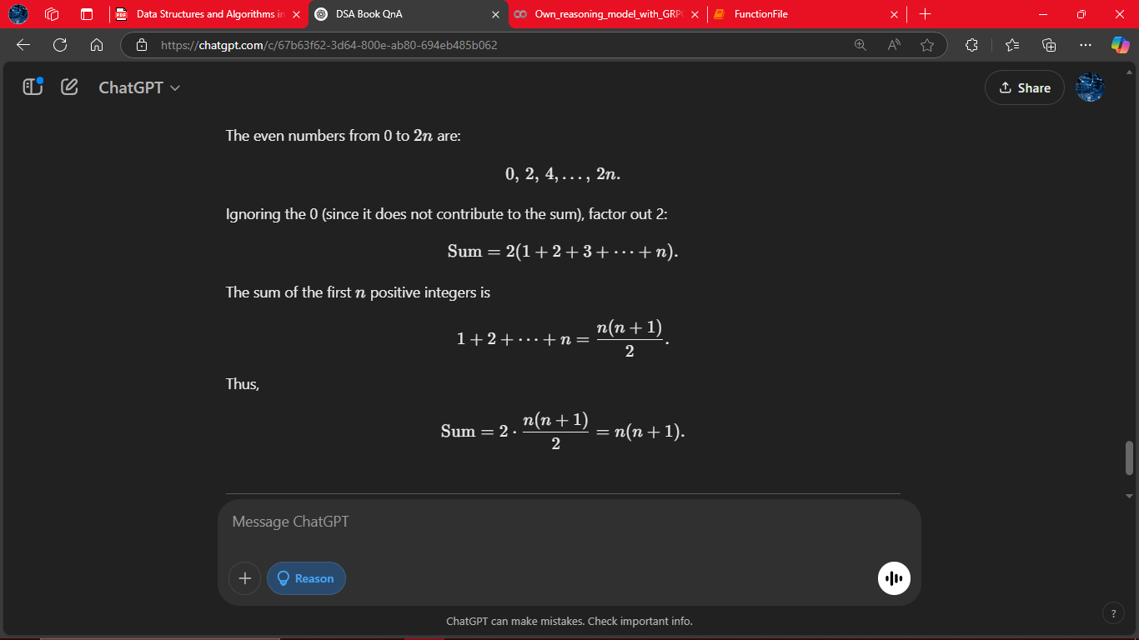
# Answer 7
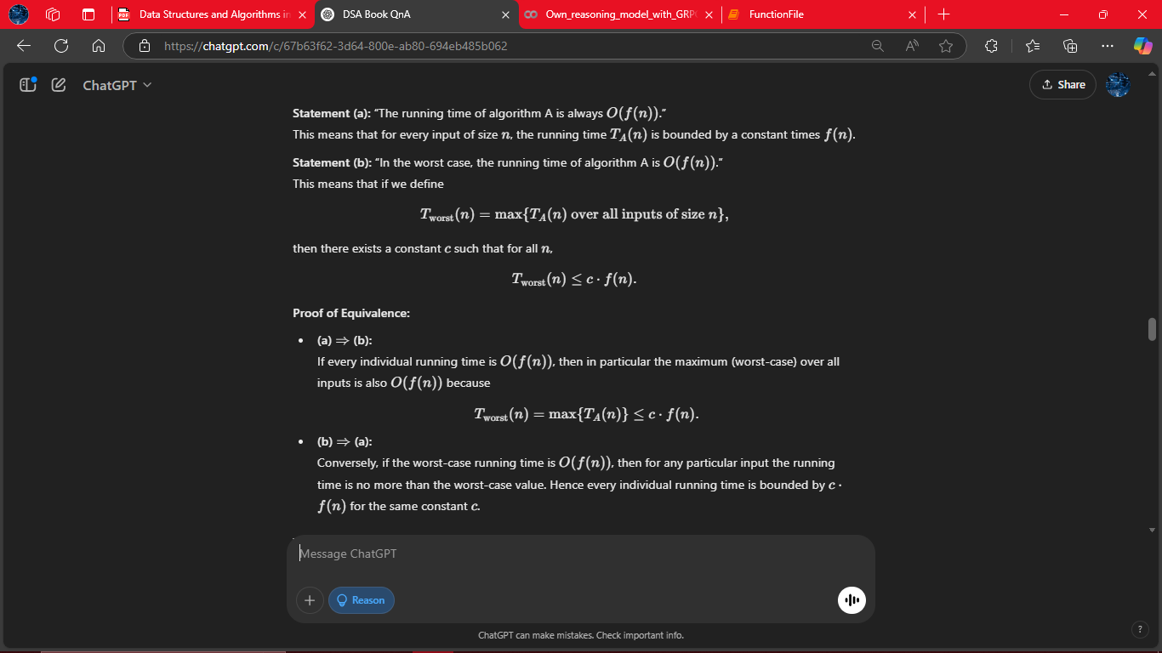
# Answer 8

# Answer 9
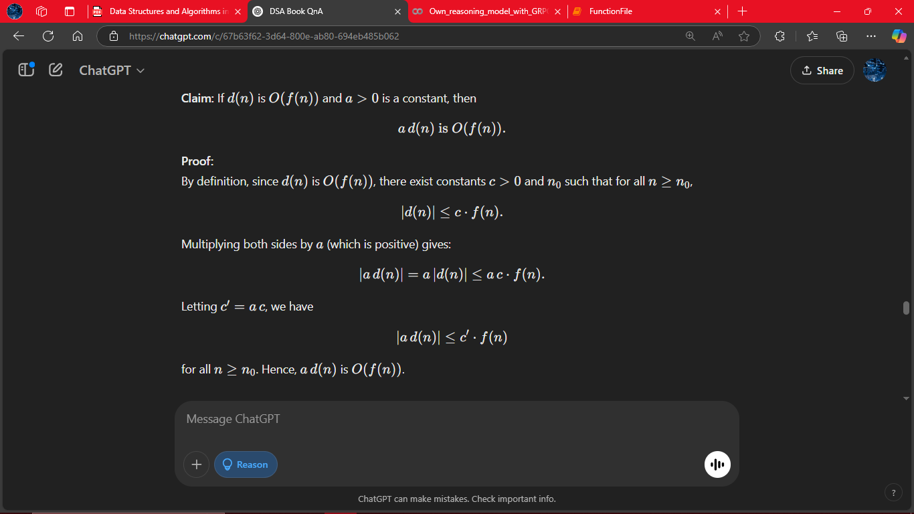
# Answer 10
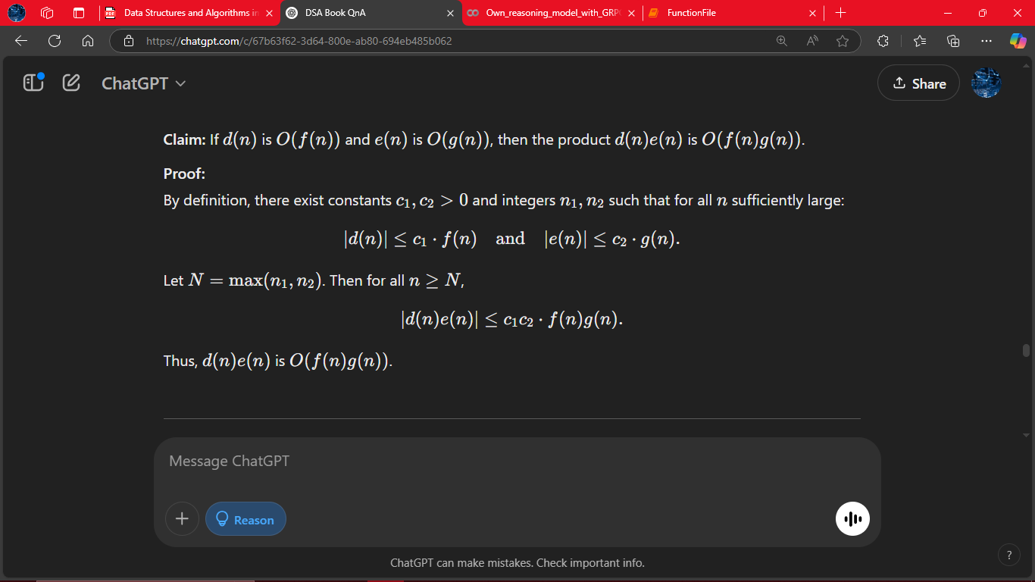
# Answer 11
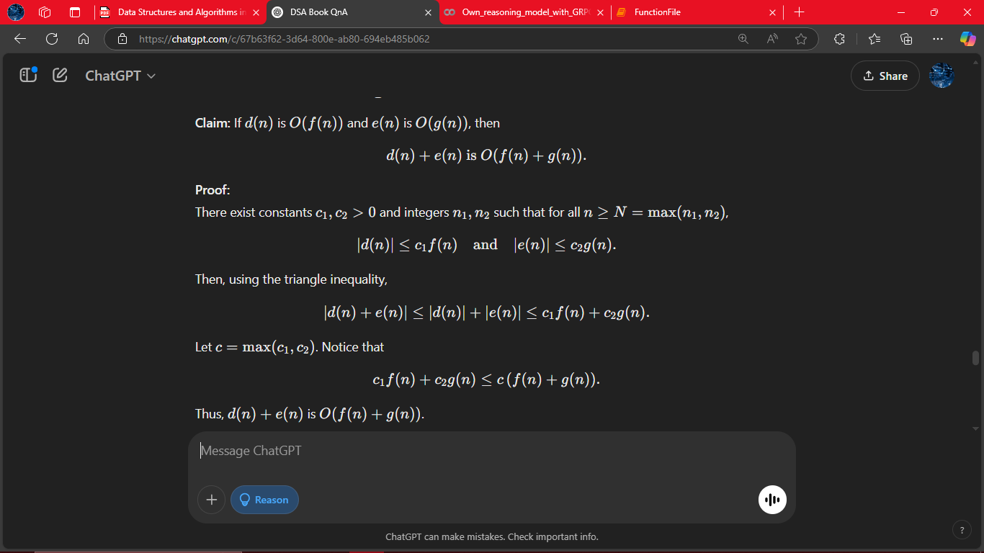
# Answer 12
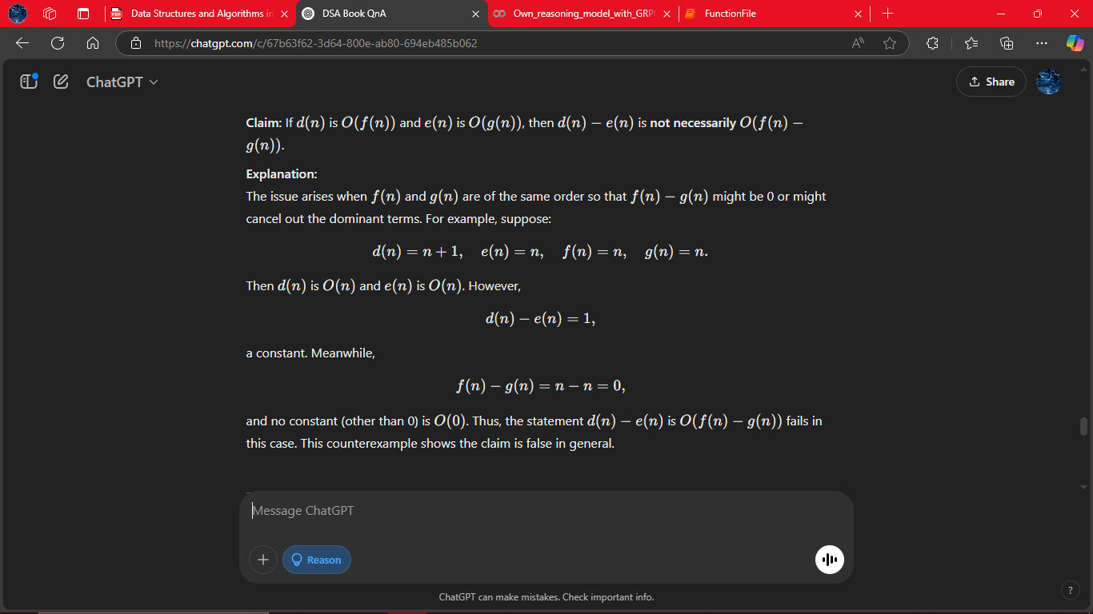
# Answer 13
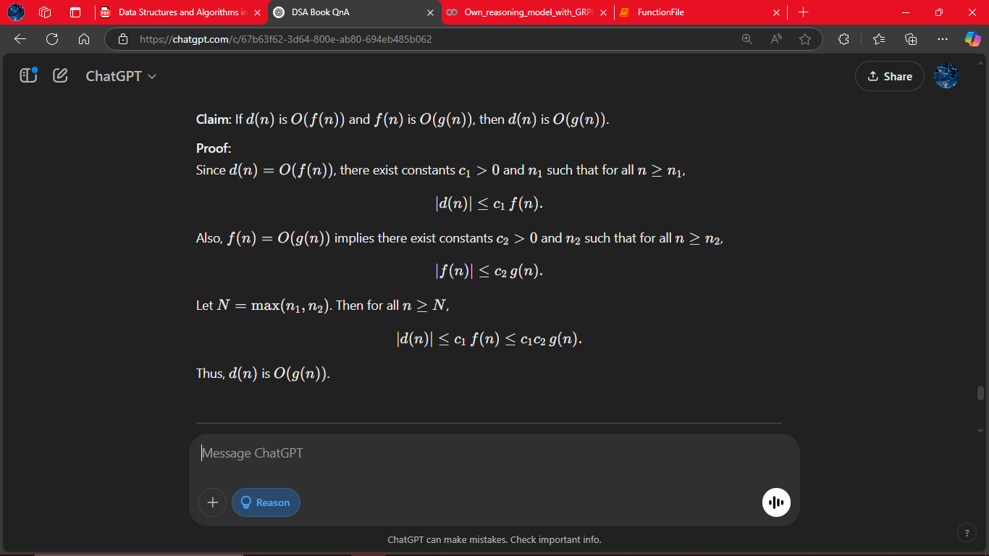
# Answer 14
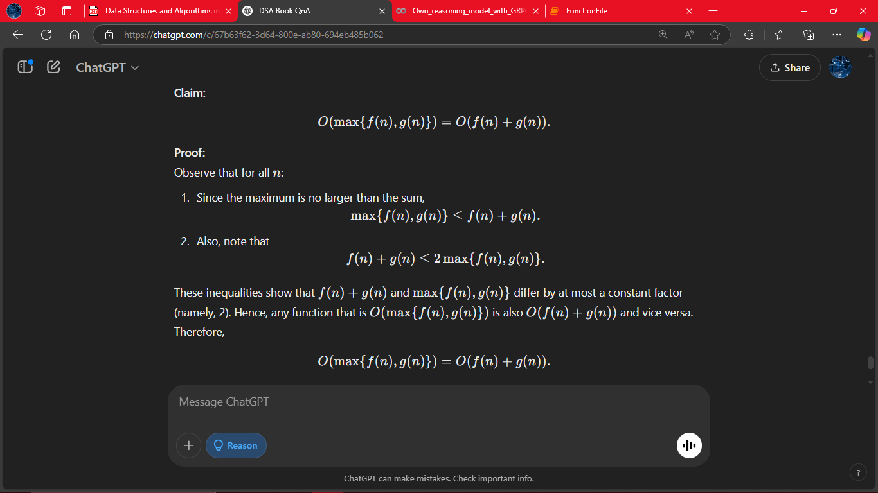
# Answer 15
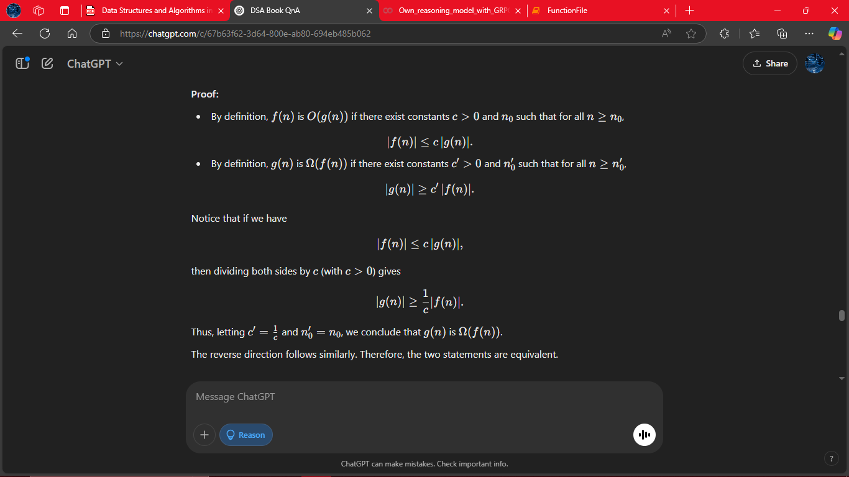
# Answer 16
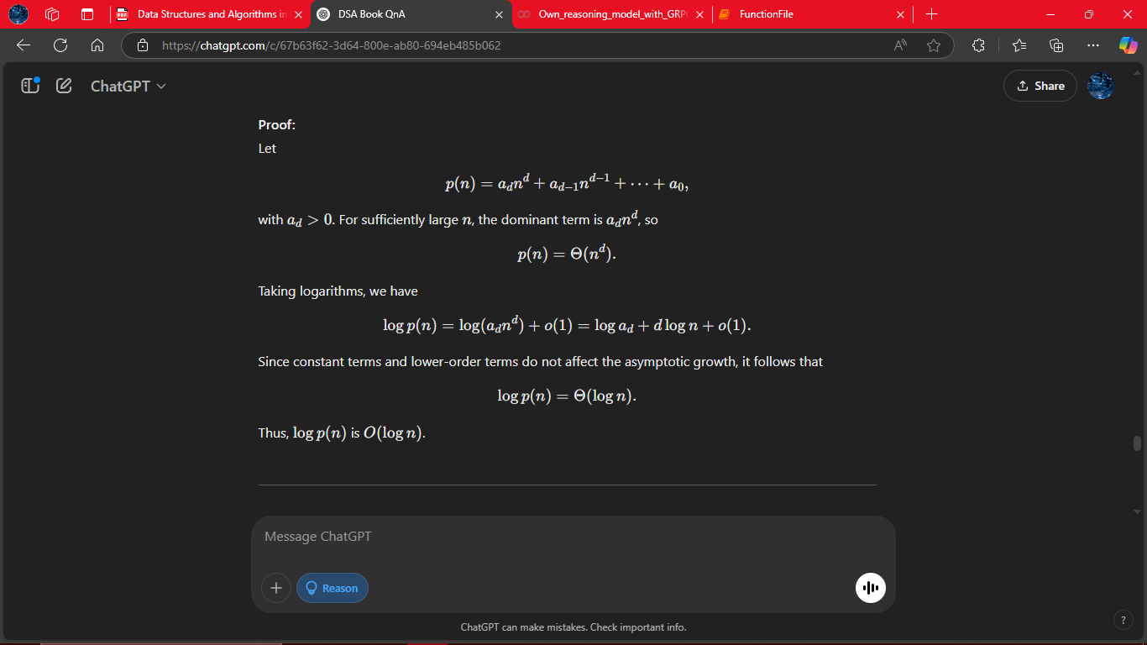
# Answer 17
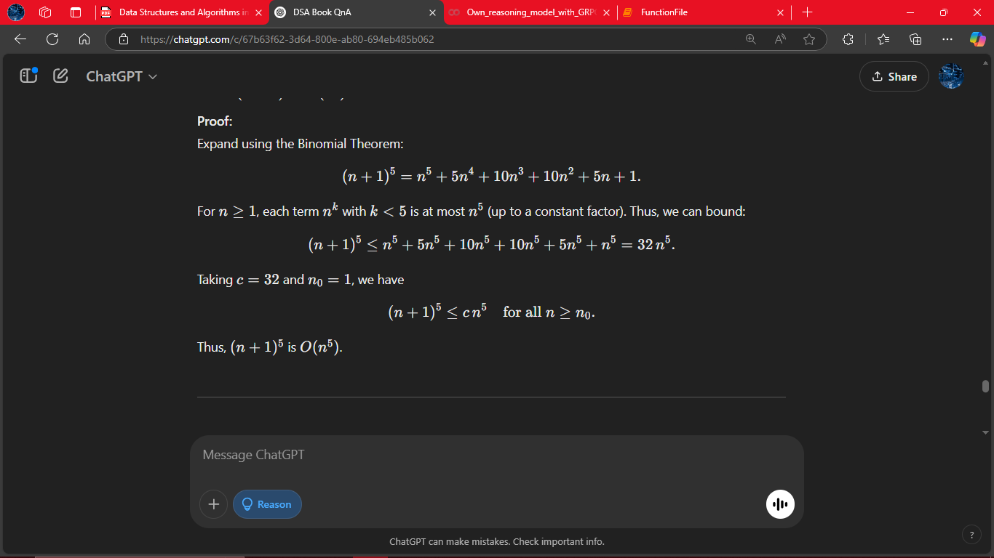
# Answer 18
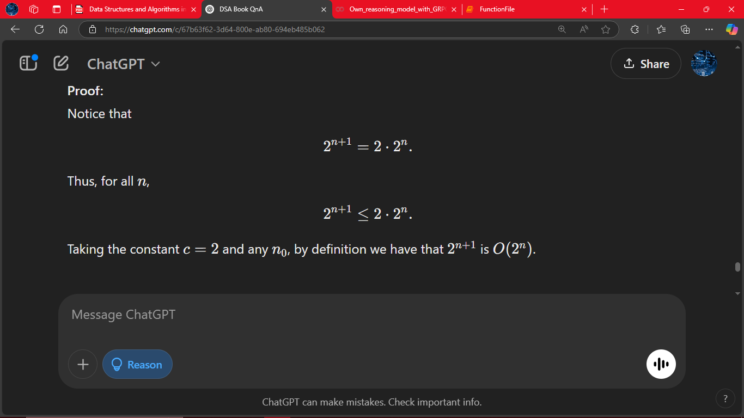# Answer 19
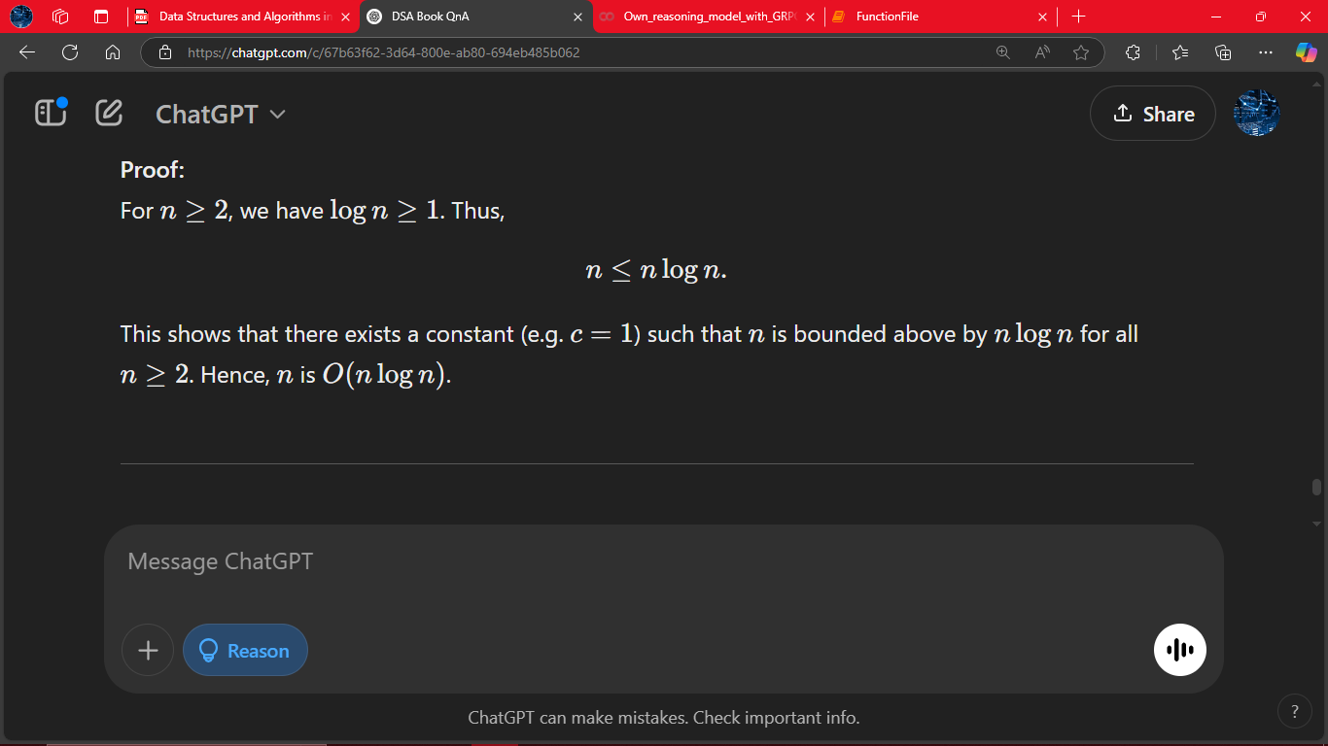
# Answer 20
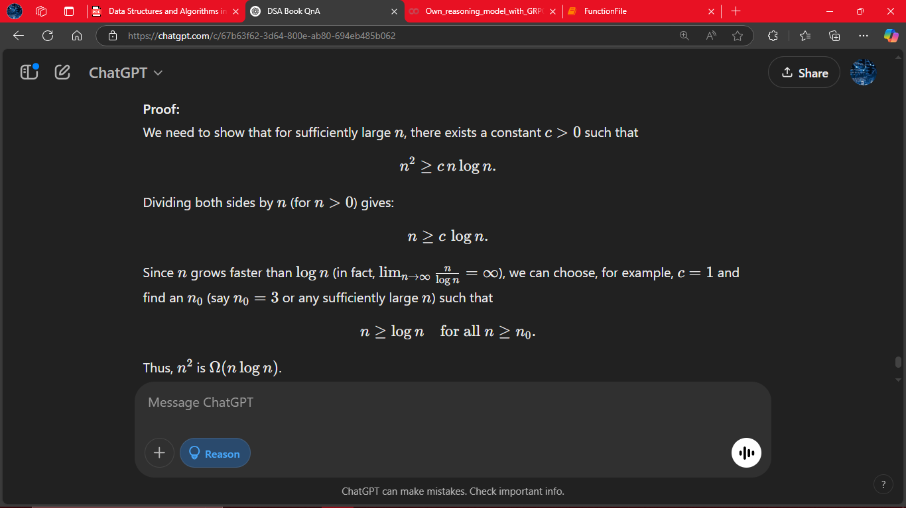
# Answer 21
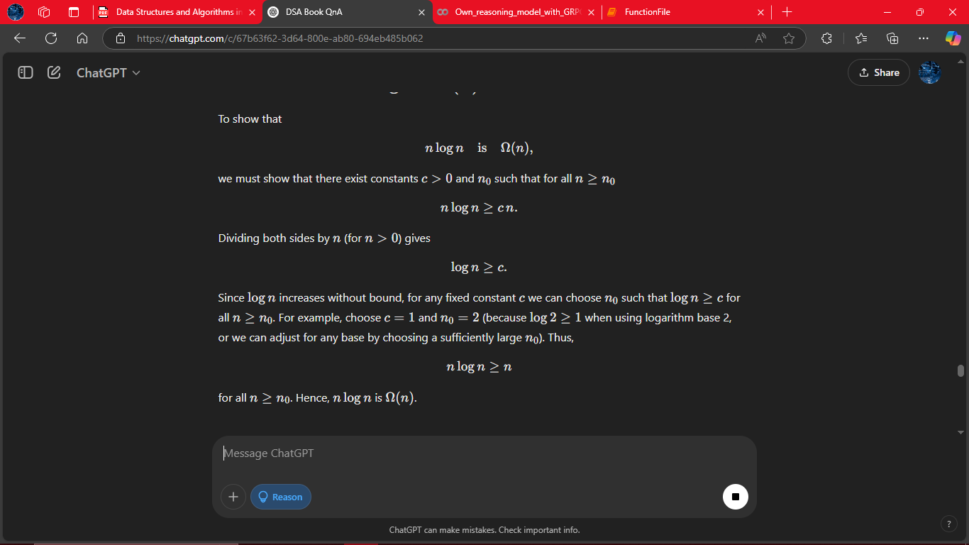
# Answer 22
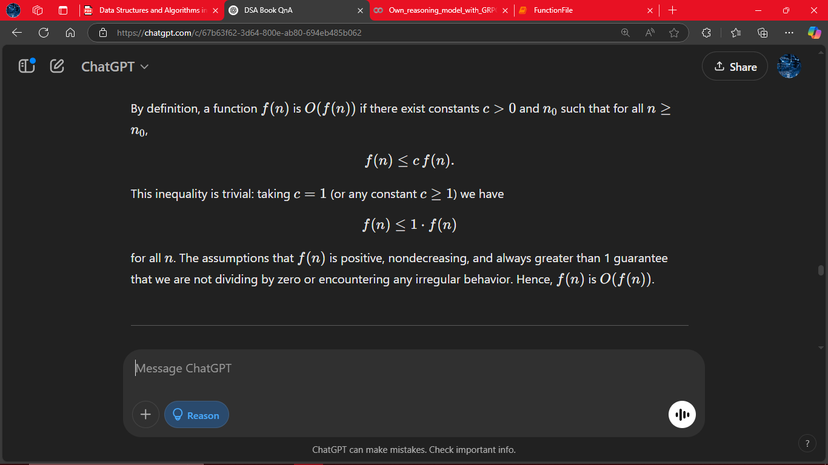
# Answer 23 to 27
O(n), O(n), O(n^2), O(n), O(n^3)
# Answer 28
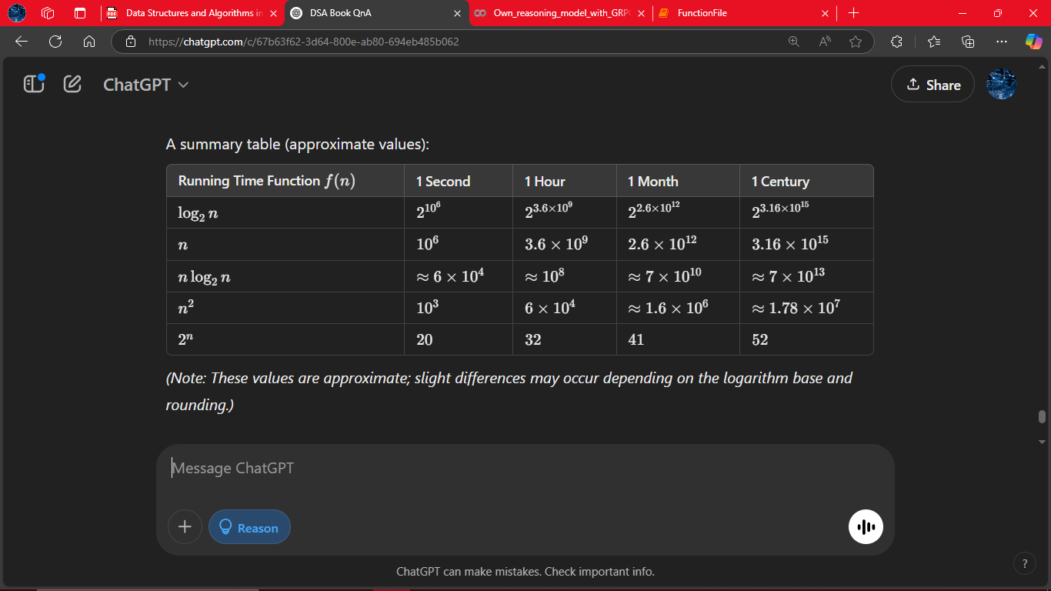
# Answer 29
The problem states that Algorithm A performs an O(log(n)) computation for each entry of an n-element sequence. Thus, if there are n entries and each takes O(log(n)) time, then the total worst-case running time is n*O(log(n)) = O(nlog(n)).
# Answer 30
The problem states that Algorithm B chooses log(n) elements at random from an n element sequence and performs an O(n) time calculation for each chosen element. Therefore, the total running time is O(n[per chosen element]*log(n)[number of choices]) = O(log(n)).
# Answer 31
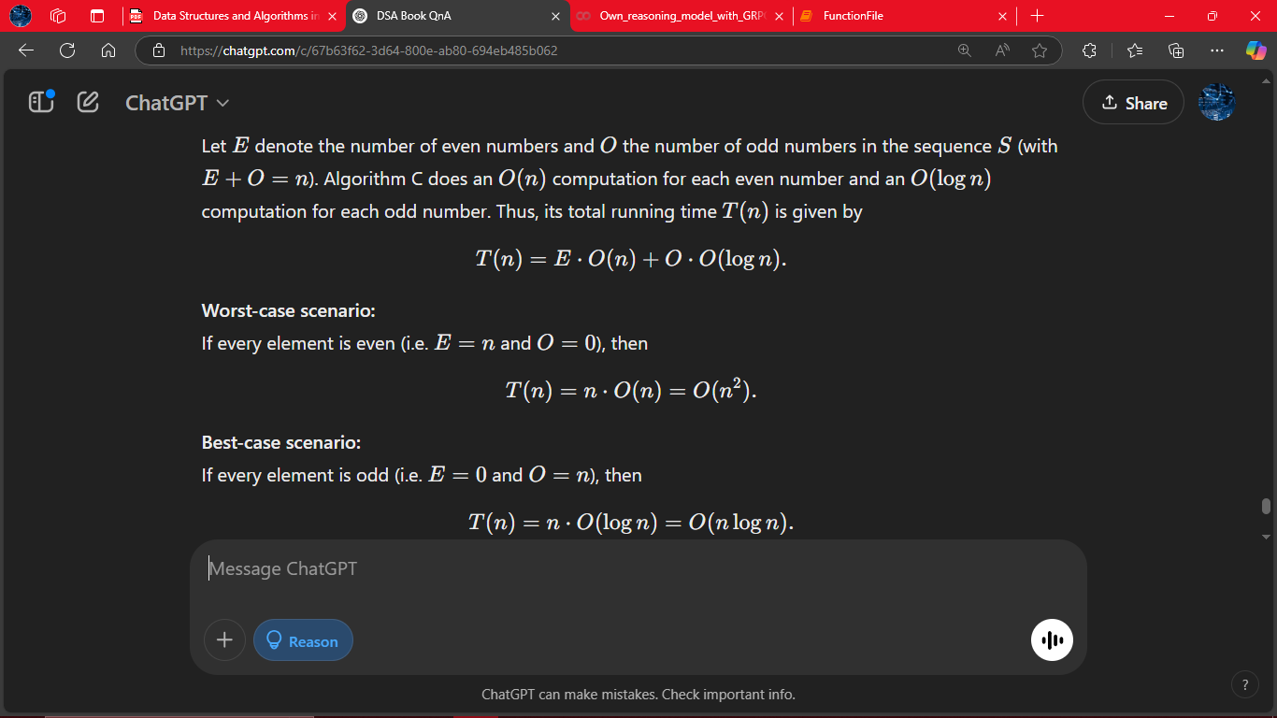
# Answer 32
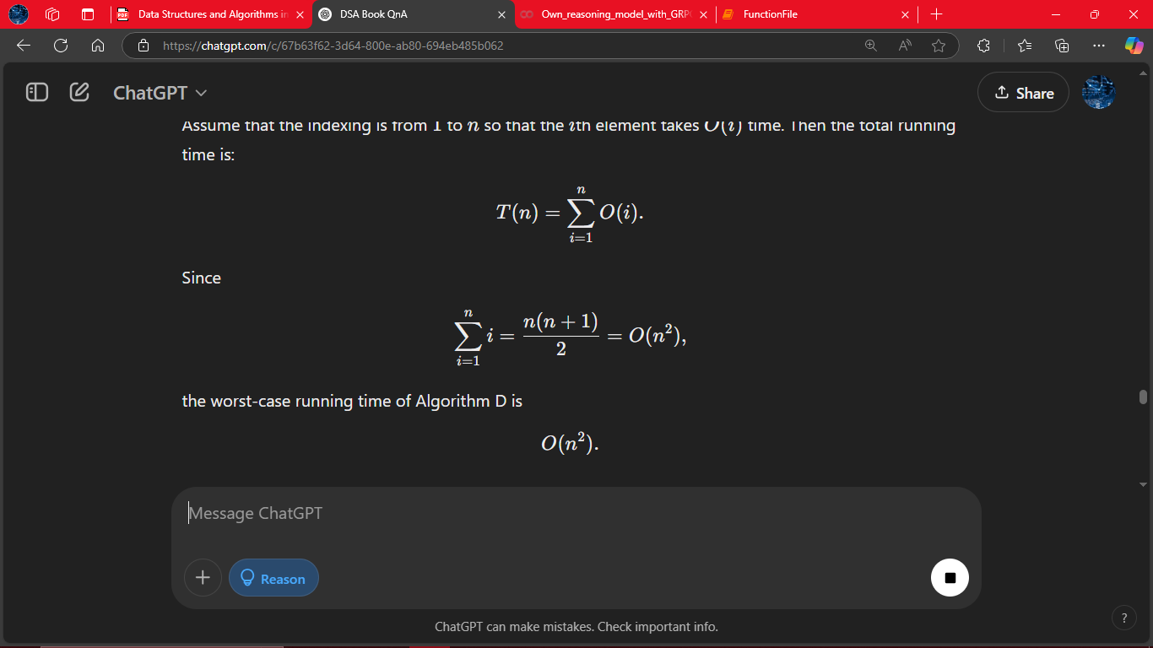
# Answer 33
Big-O notation describes asymptotic behavior as n grows large, ignoring constant factors and lower-order terms. In practice, an algorithm with an O(n^2) running time might have a very small constant factor or overhead, while the O(nlog(n)) algorithm might have a large constant factor. Consequently, for small problem sizes (e.g. n < 100) the O(n^2) algorithm can be faster. However, as nnn increases, the higher-order term in n^2 eventually dominates, and the O(nlog(n)) algorithm becomes faster. This phenomenon shows that asymptotic analysis does not account for constants or practical overhead.
# Answer 34
An inhabitant is happy only when a meal is a “record high” in quality. If a person experiences n meals (with qualities that are independent and uniformly distributed), the expected number of record highs is: H(n)​=1+1/2​+1/3​+⋯+1/n​≈ln(n)+γ,
where γ is the Euler–Mascheroni constant. Thus, the expected number of meals that make them happy is Θ(log(n)).
# Answer 35
• Step 1: Sort each of the three sets in O(nlog(n)) time.
• Step 2: Use a three-way merge (with three pointers) to scan through the sorted lists in O(n) time.
Total => O(nlog(n)) + O(n) = O(nlog(n)).
# Answer 36
Maintain a min-heap of size 10:
Process each of the n elements, inserting into the heap if its size is less than 10 or replacing the minimum if the current element is larger. Each heap operation takes O(1) time (since the heap size is constant), leading to a total running time of O(n).
# Answer 37
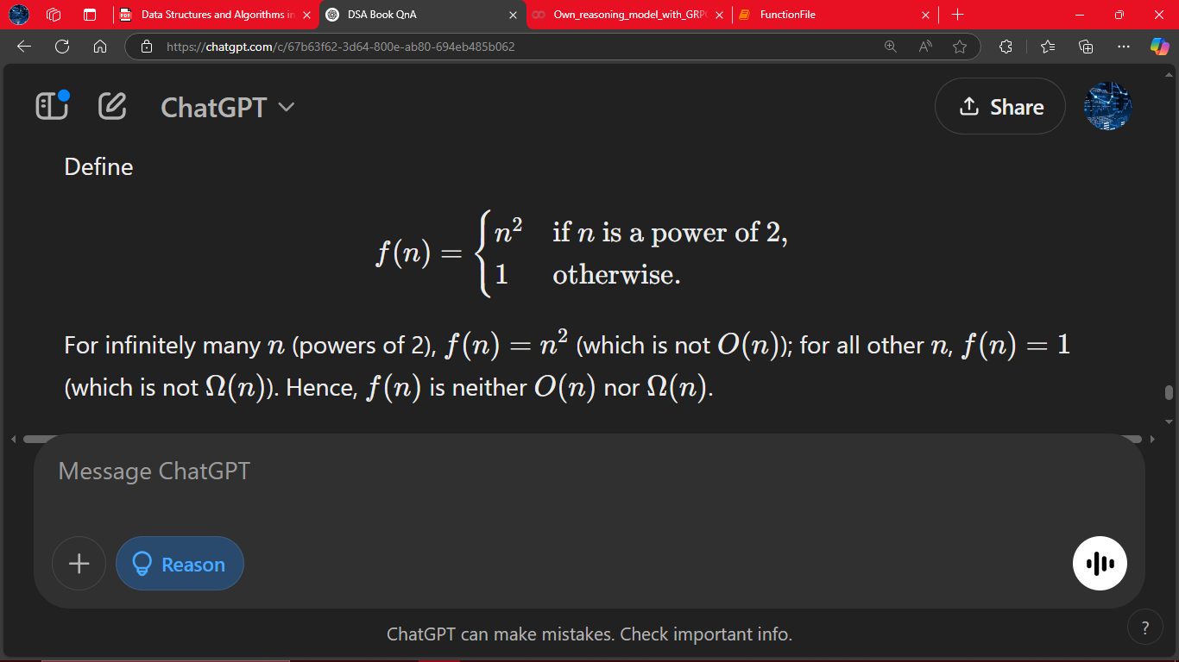
# Answer 38
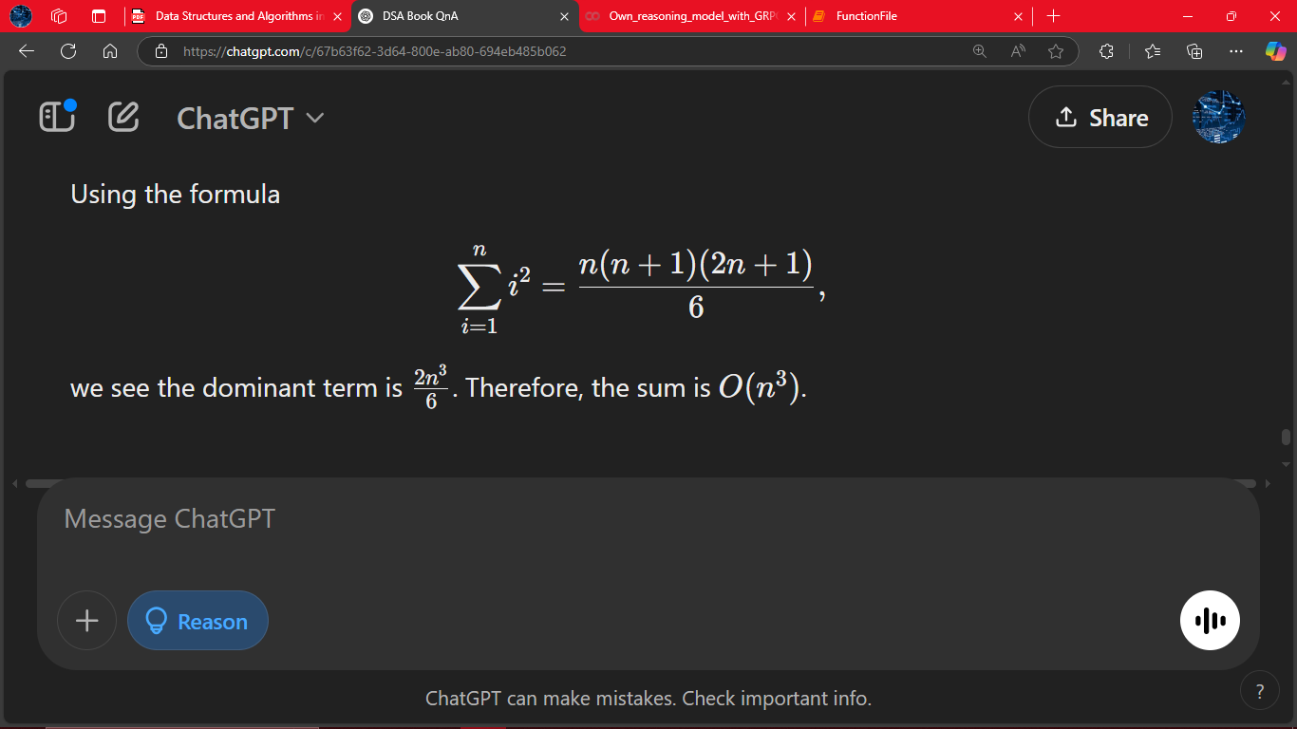
# Answer 39
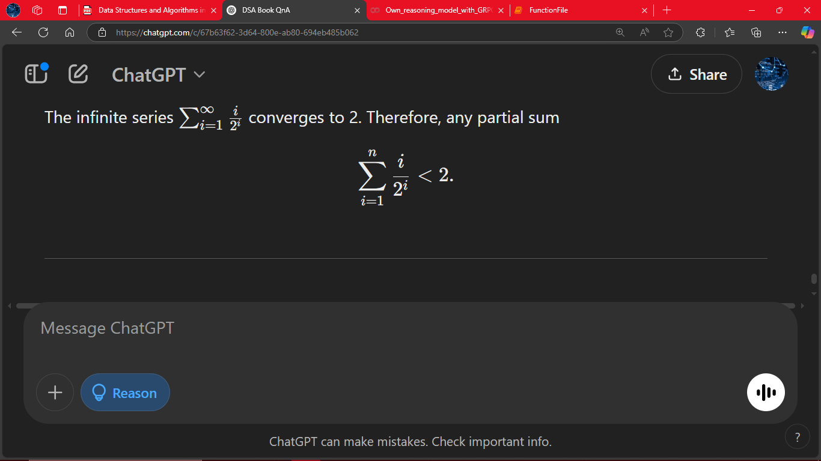
# Answer 40
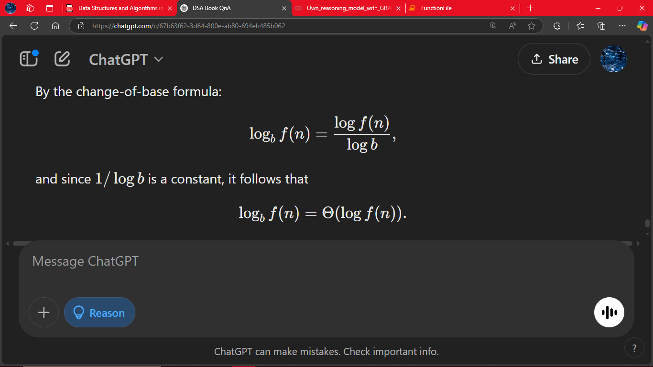
# Answer 41
1.Initialization:
If n is even: Compare the first two elements. Let the smaller become the initial min and the larger the initial max.
If n is odd: Set the first element as both min and max. Then start pairing from the second element.
2. Pairwise Comparison: Process the remaining numbers two at a time. For each pair (a,b):
Compare a and b.
– Suppose a ≤ b Then a is a candidate for the minimum and b is a candidate for the maximum.
Compare the candidate minimum (a) with the current min; update if needed.
Compare the candidate maximum (b) with the current max; update if needed.
Each pair requires 3 comparisons.
3. Comparison Count: For even n: 1 initial comparison, plus 3 x (n-2)/2 comparisons
Total = 1 + (3n-6)/2 = (3n-4)​/2 comparisons, which is fewer than 3n/2.
For odd n:
With one unpaired element, a similar analysis shows the total comparisons remain below 3n/2.
# Answer 42
Setup:
Bob’s n friends are numbered 1 through n. Friend i is allowed to visit at most i times. Bob only knows the total number of visits C, but not who made them.
Observation:
If no friend has reached his/her maximum allowed visits, then friend i must have visited at most i−1 times. Thus, the maximum total number of visits possible without any friend “maxing out” is: ∑ i=1 to n {(i−1)}=0+1+2+⋯+(n−1)=n(n−1)/2 Conclusion:
If Bob’s counter shows more than n(n-1)/2 visits, then by the pigeonhole principle at least one friend must have visited the maximum number of times allowed. Thus, the minimum value for C that guarantees this is: C = n(n-1)/2.
# Answer 43
For n odd:
1.Pairing: With an odd number of elements, one element remains unpaired in the first round.
2.Tournament Trees:
For Candidate Maximums:
– Draw a “tournament tree” where paired winners (the larger in each pair) compete in successive rounds. The unpaired element must also be compared appropriately to join this tree. For Candidate Minimums:
– Similarly, the smaller elements in each pair form a tournament for the minimum. The unpaired element is also inserted by comparing it with the current candidate minimum. 3. Key Point:
Each comparison in these trees “eliminates” one candidate from being the overall min or max. Even with one extra (unpaired) element, the extra comparisons required do not increase the total by more than what is allowed by the analysis for fewer than 3n/2 comparisons.
A Sample Diagram (for n = 5):
Initial Pairing:
(A, B), (C, D) and unpaired E

For Maximum:
A vs B and C vs D
| |
max₁ max₂
\ /
--- ? --- <-- Compare winner with E
Overall max

For Minimum:
A vs B and C vs D
| |
min₁ min₂
\ /
--- ? --- <-- Compare loser with E
Overall min
# Answer 44
Part (a): Time Estimate
Given:
– r is a 100-bit number, so r ≈ 2^100
– A division takes 1 microsecond.
Observation:
– To find the smallest factor p (which is at most sqrt(2)​), the worst-case scenario requires about sqrt(2) ≈ 2^50 divisions.
Calculation:
– Total time in microseconds ≈ 2^50 ≈ 1.1259×10^15 microseconds. – Converting microseconds to seconds: 1.1259×10^15/10^6 ≈ 1.1259×10^9 seconds – Converting seconds to years (using 3.16×10^7 seconds per year): 1.1259×10^9/(3.16x10^7) ≈ 35.6 years.
In the worst case, it would take on the order of 35 years to decipher the secret message.
(b): Worst-Case Time Complexity Loop Analysis:
– The loop runs from 2 to (roughly) sqrt(r), giving O(sqrt(r)​) iterations. Division Cost:
– Each division takes O(n) time where the input size [n = (log(with base 2)r/8) +1] Expressing in Terms of n:
– Since r is a 100-bit number, in general r ≈ 2^(8(n−1)r). Thus, sqrt(r) = 2^(4(n−1)r).
Overall Complexity:
– The worst-case time complexity is: O(n.sqrt(r)) = O(n. 2^(4(n−1)r)). – In other words, the algorithm runs in exponential time with respect to the input size n.
# Answer 45
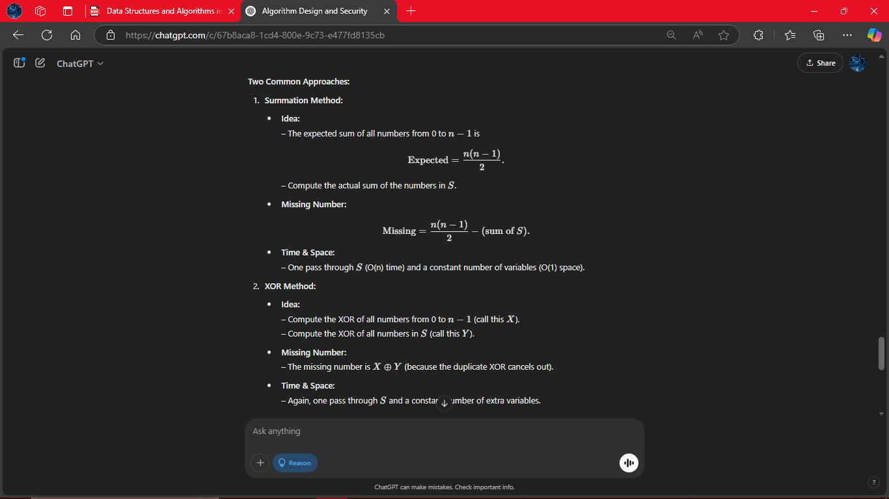
# Answer 46
Al’s “Proof”:
1.Base Case: A single sheep is trivially the same color as itself.
Induction Step: For a flock of n sheep, remove one sheep (say, a) so that the remaining n−1 are, by induction, all the same color. Then replace a and remove a different sheep b; again, the remaining n−1 are all the same color. Since the two groups overlap (they both contain n−2 common sheep), a and b must be the same color.
2.What’s Wrong:
The error occurs in the induction step when n = 2. In that case, if you remove one sheep, the remaining “group” consists of a single sheep. Then when you remove the other sheep, there is no overlapping element between the two groups to “link” their colors. Without a common element, you cannot conclude that the two sheep are of the same color. Thus, the proof fails for the smallest nontrivial case, and the induction is invalid.
# Answer 47
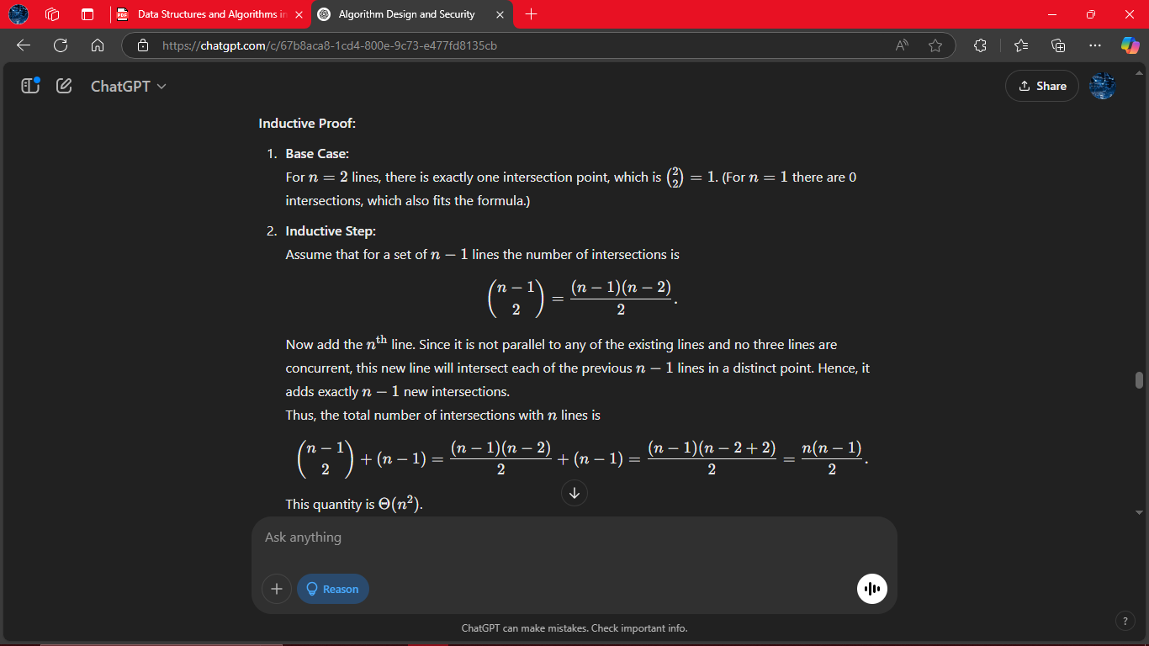

# Answer 48
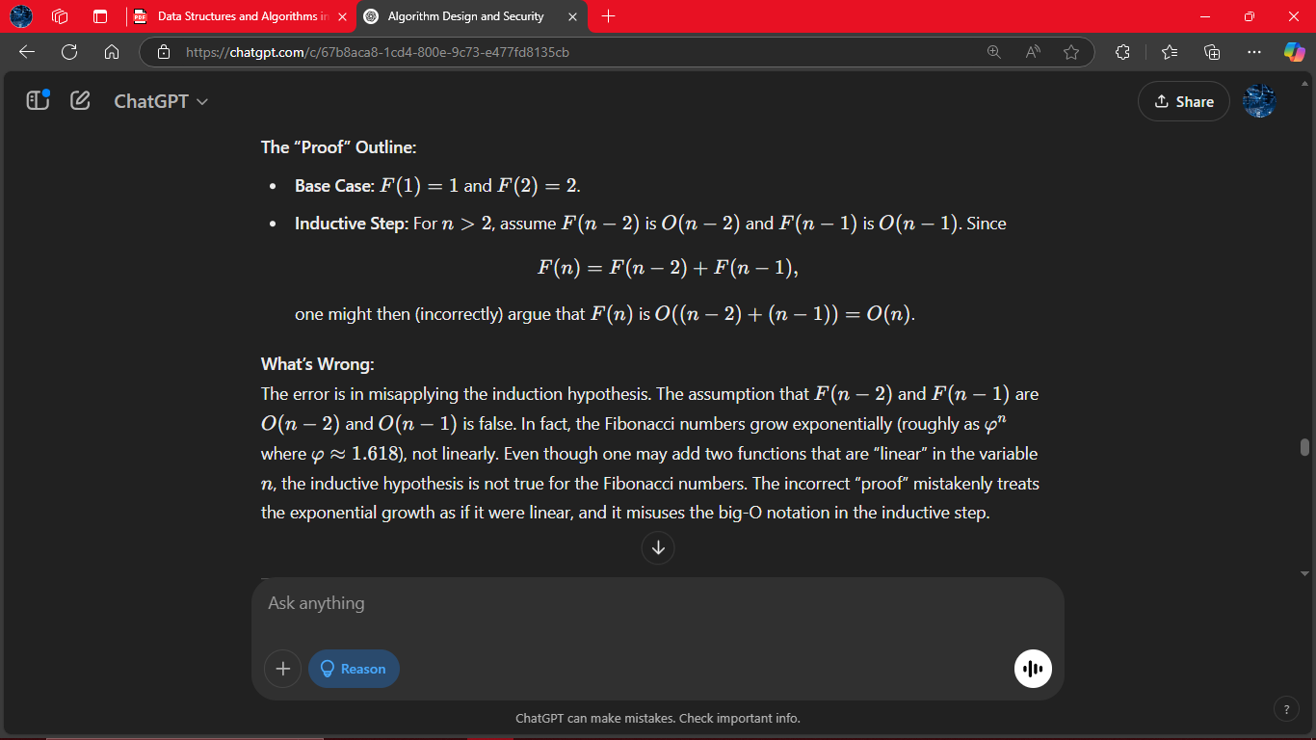

# Answer 49
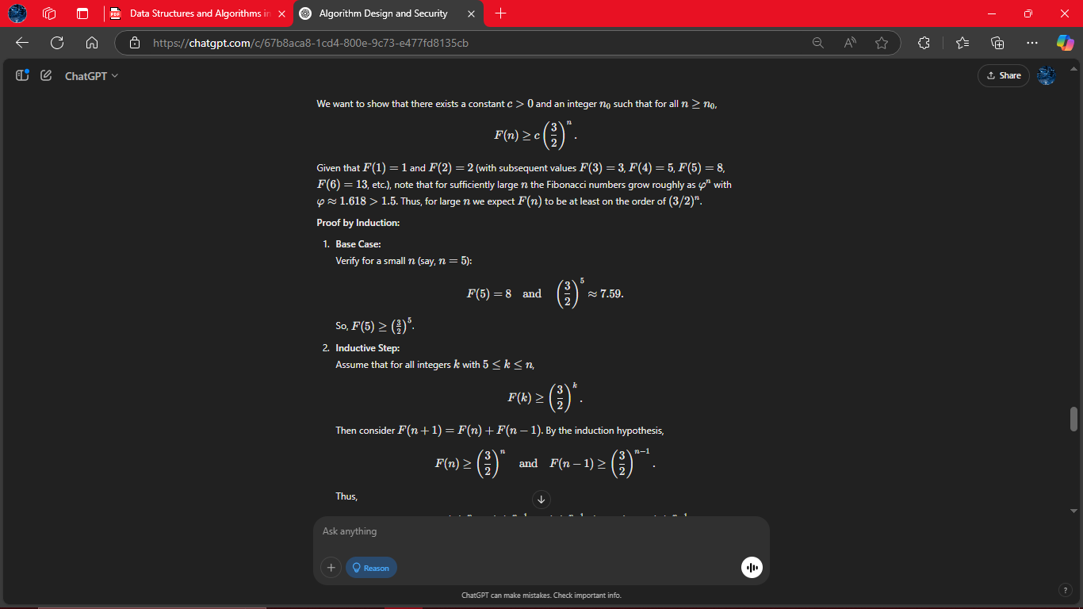
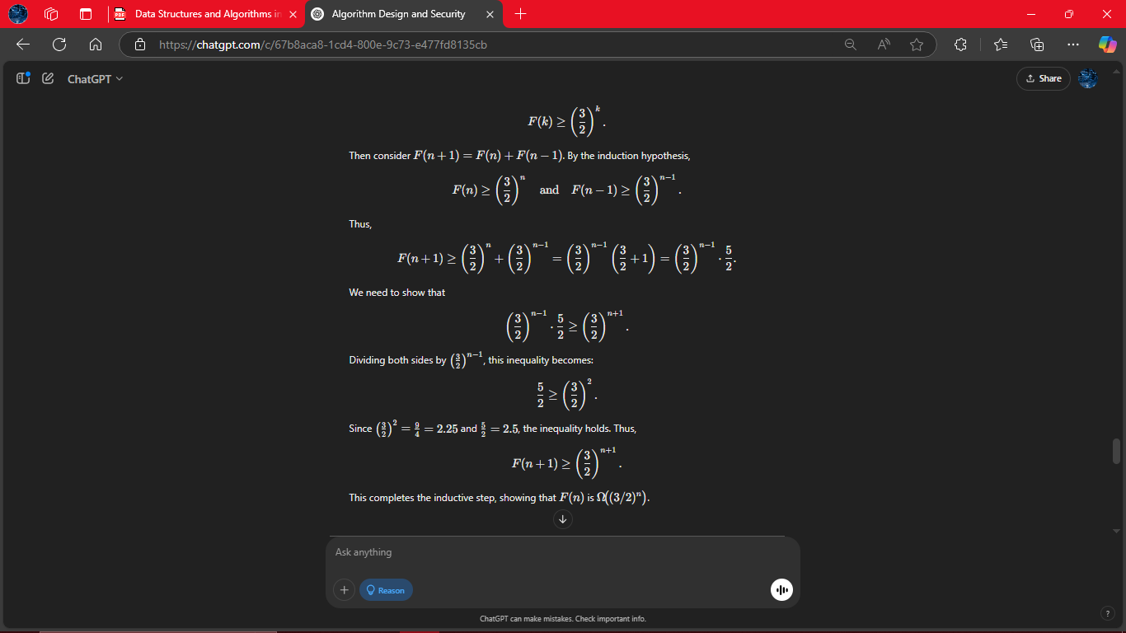
# Answer 50
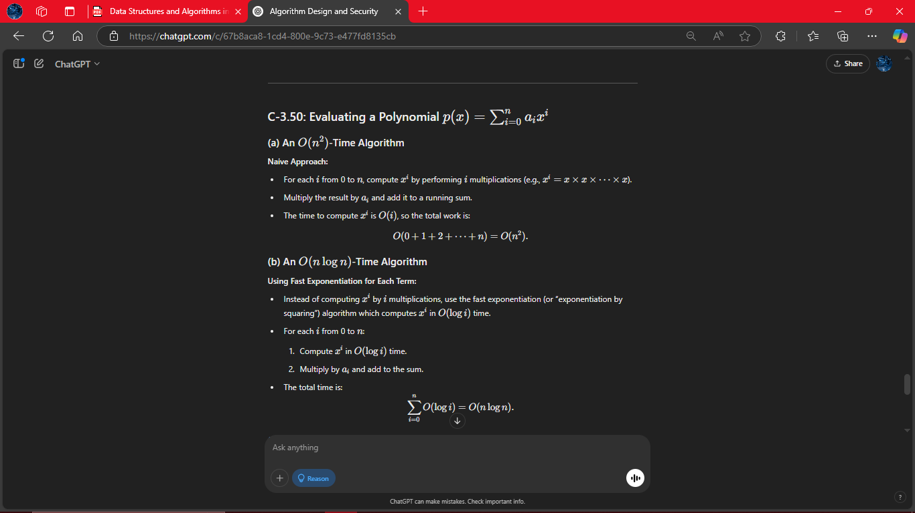

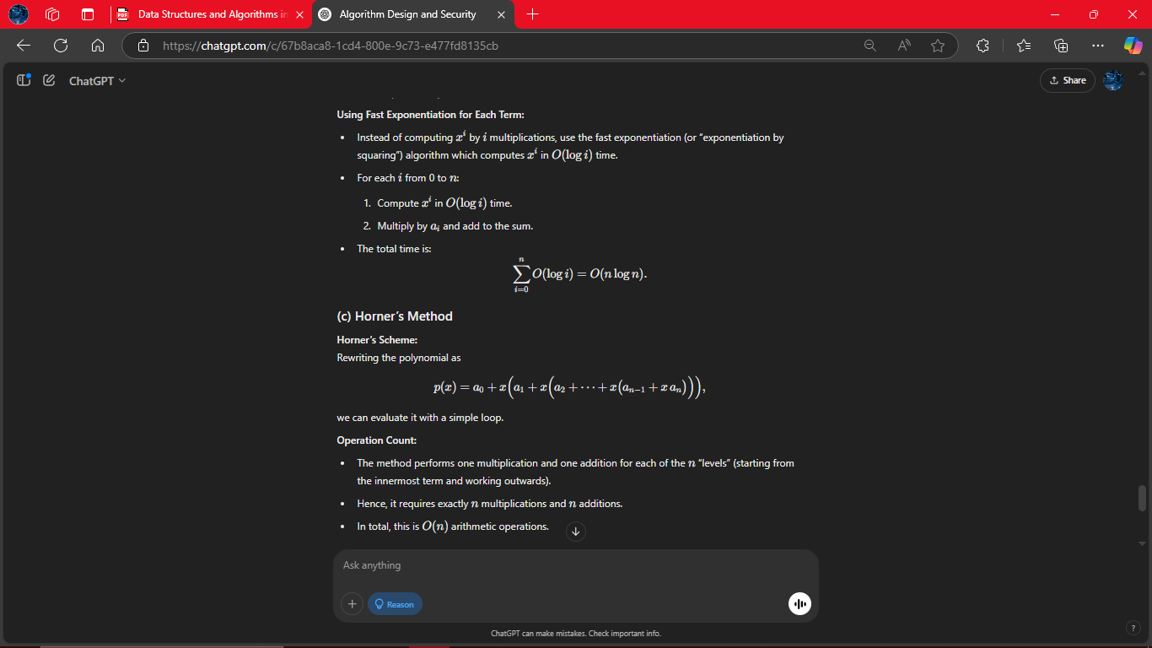
# Answer 51
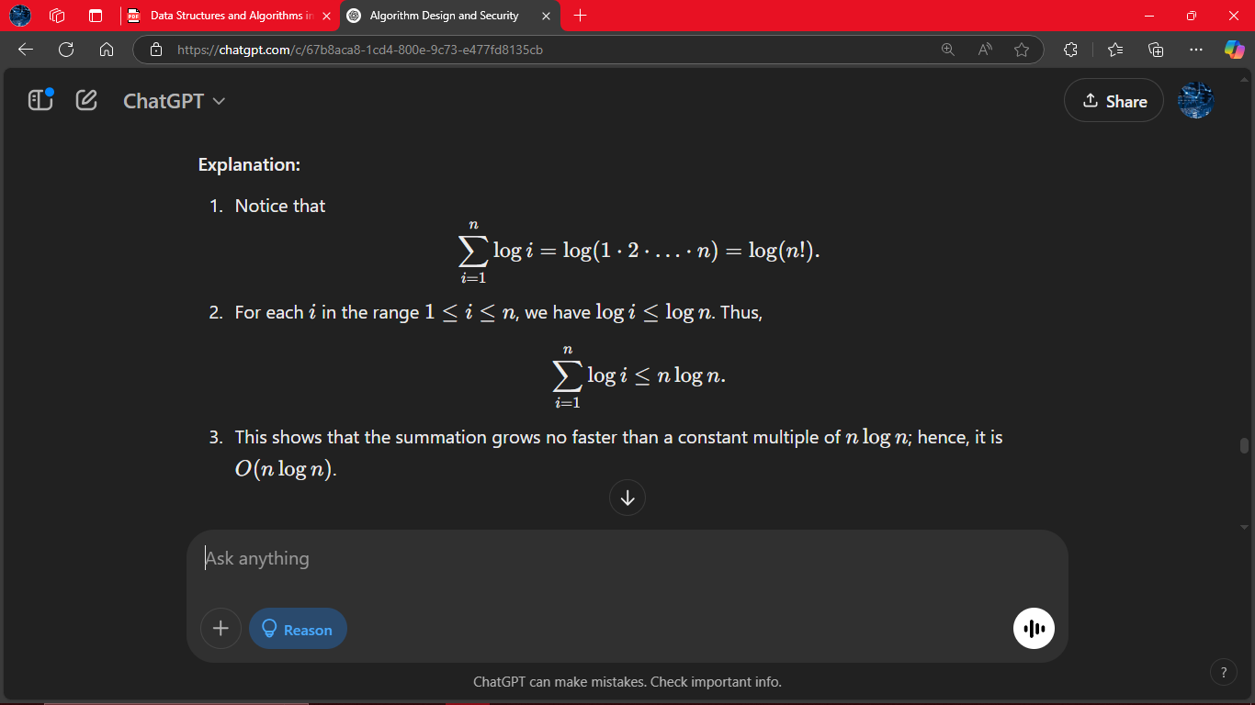

# Answer 52
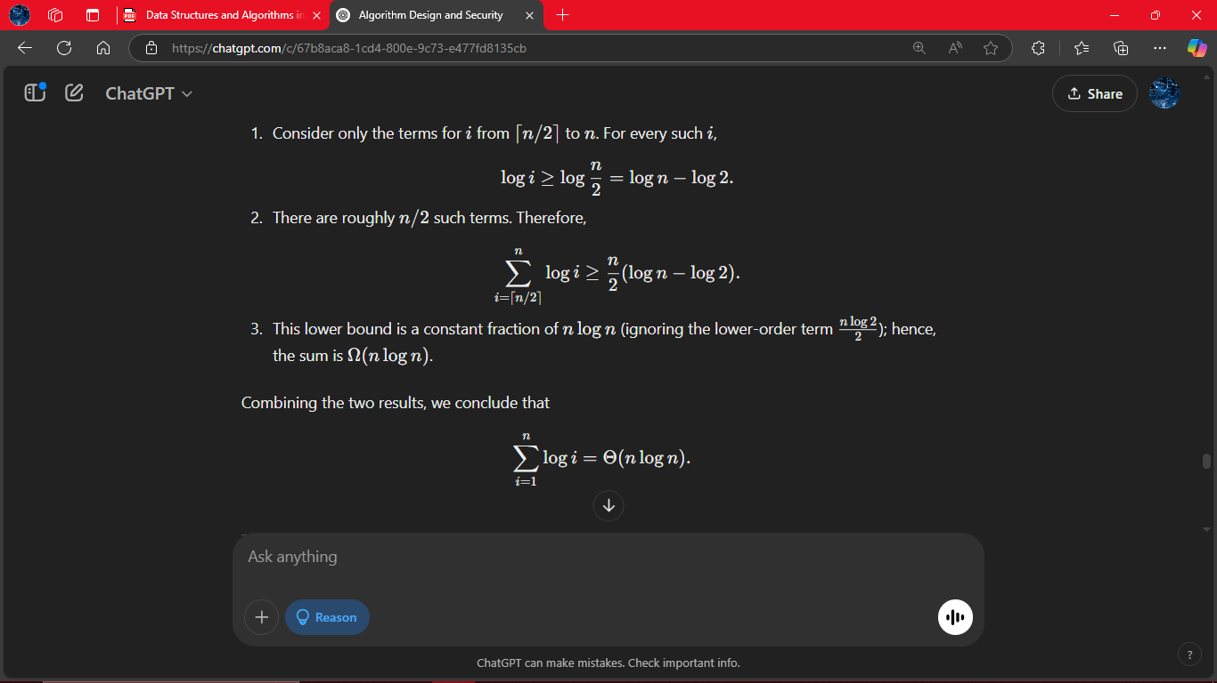
# Answer 53
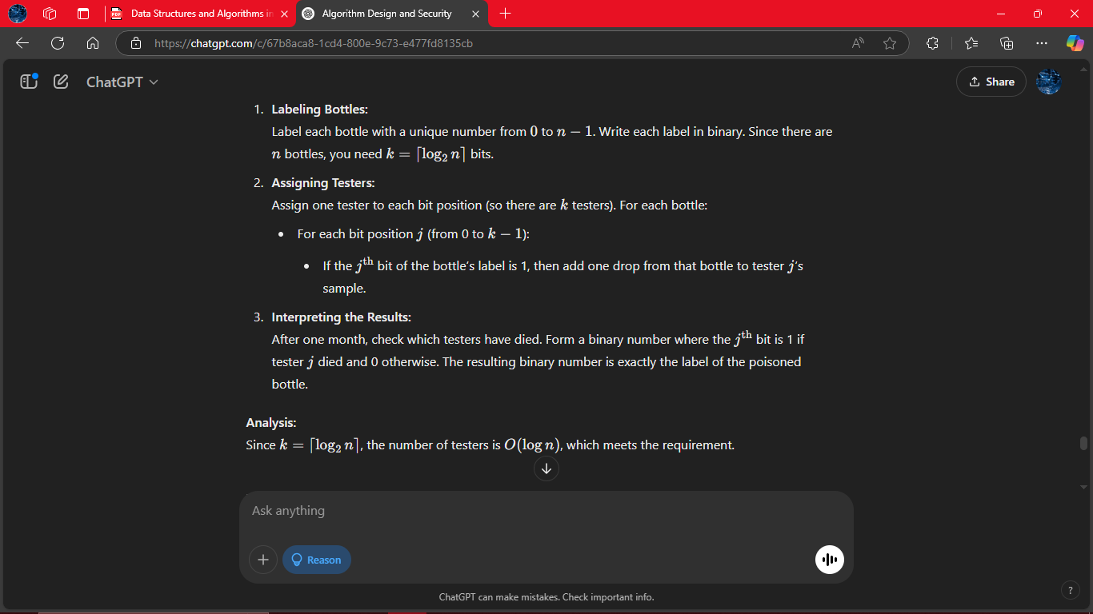
# Answer 54
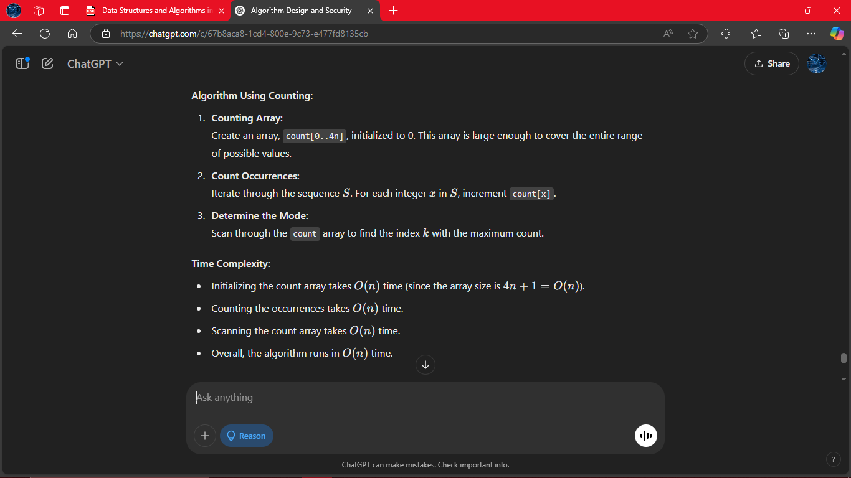

# Answer 55
Refer FunctionFile.ipynb
# Answer 56
Refer FunctionFile.ipynb
# Answer 57
1.Hypothesis:
Python’s built-in sorted() function (which uses Timsort) runs in average-case time O(nlogn).
2.Generate Data:
For various values of n (e.g. 10^3,10^4,10^5, …), generate random lists (or arrays) of n numbers.
3.Measure Running Time:
Time how long sorted() takes to sort these lists. Again, average over several runs for each n to reduce measurement noise.
4.Visualization & Analysis:
Log–Log Plot: Plot the running times vs. n on a log–log chart.
Ratio Test: Alternatively, compute T(n)/(nlogn) for each n and check whether the ratio stabilizes to a constant.
Expected Outcome: The data should be consistent with O(nlogn) performance.
# Answer 58
Refer FunctionFile.ipynb

